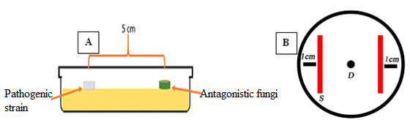

Figure 1. Confrontation methods (A: pathogens-antagonistic fungi ; B: bacteria-pathogens ; D: pathogen disc ; S: two streaks of Bacillus sp.).

