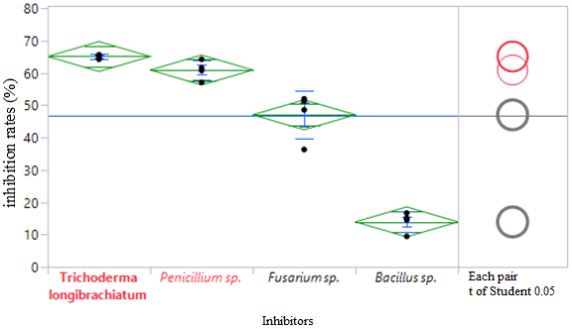
Figure 4. ANOVA- One-factor inhibition rates versus inhibitor

