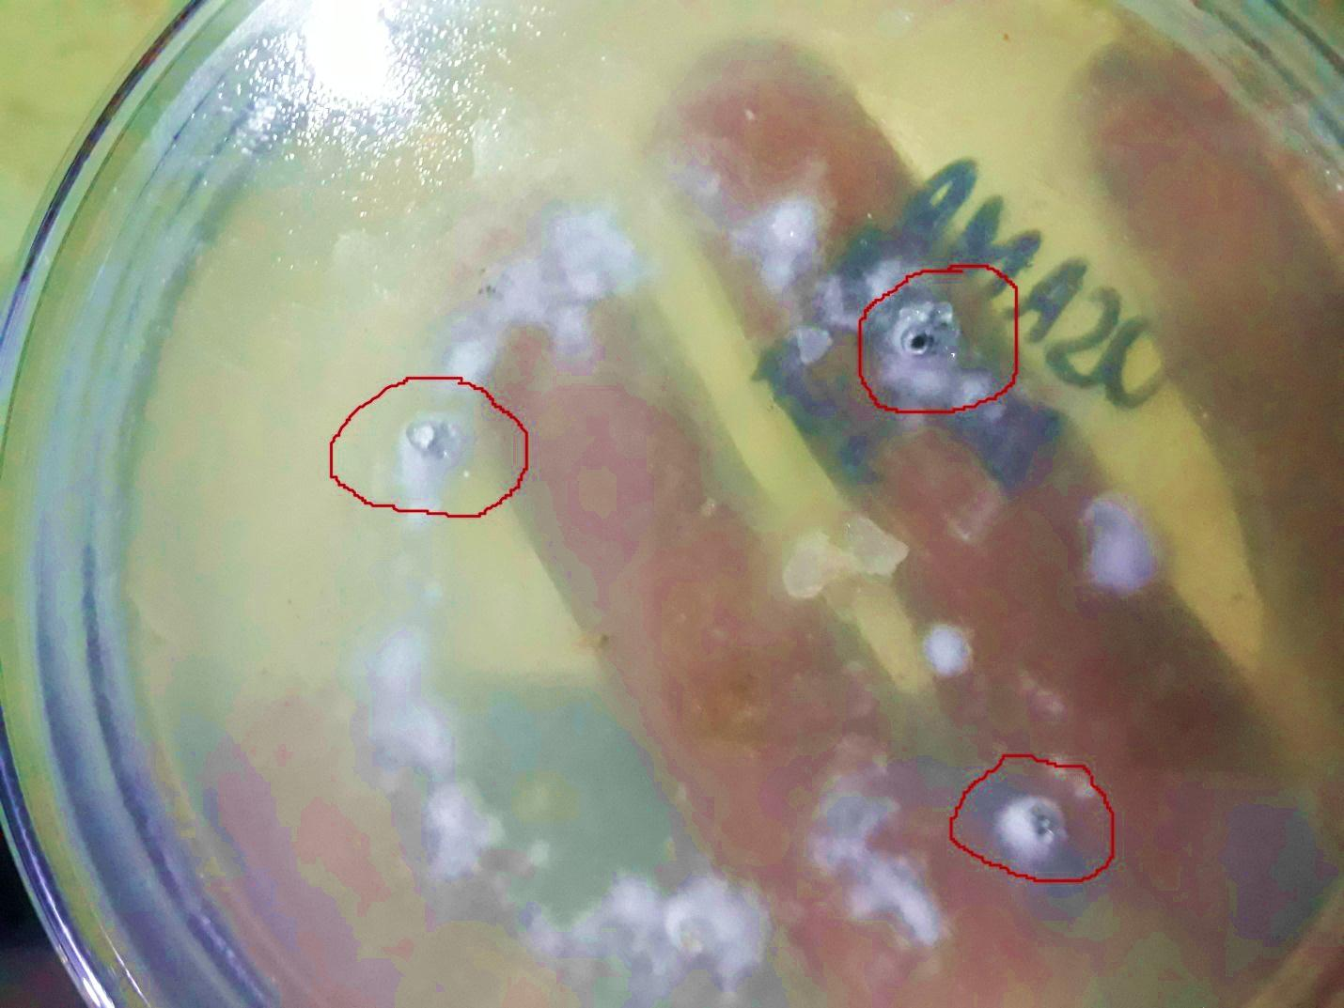
Figure 3: Fungal growth in food poison technique in control treatment. Circled are the pearl like hard sclerotia developed on cottony growth.

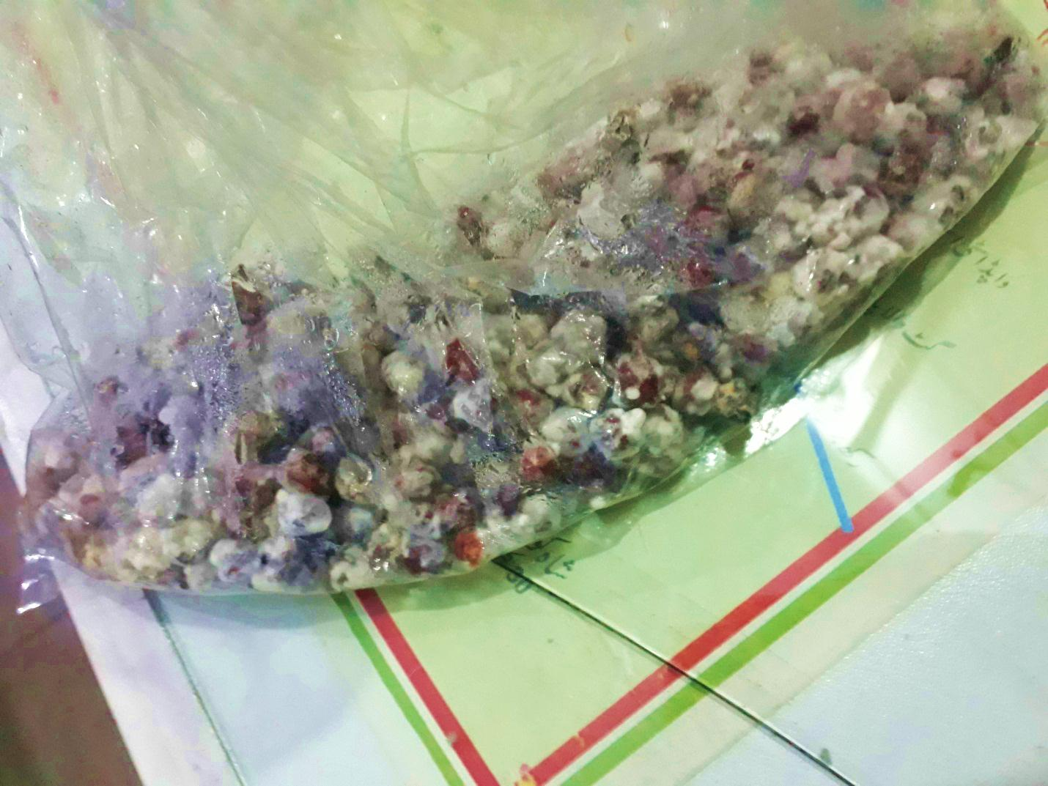
Growth of sclerotinia sclerotiorum in chickpea bags incubated to spread in field as fungal source.
Figure 4: Growth of sclerotinia sclerotiorum in chickpea bags incubated to spread in field as fungal source.

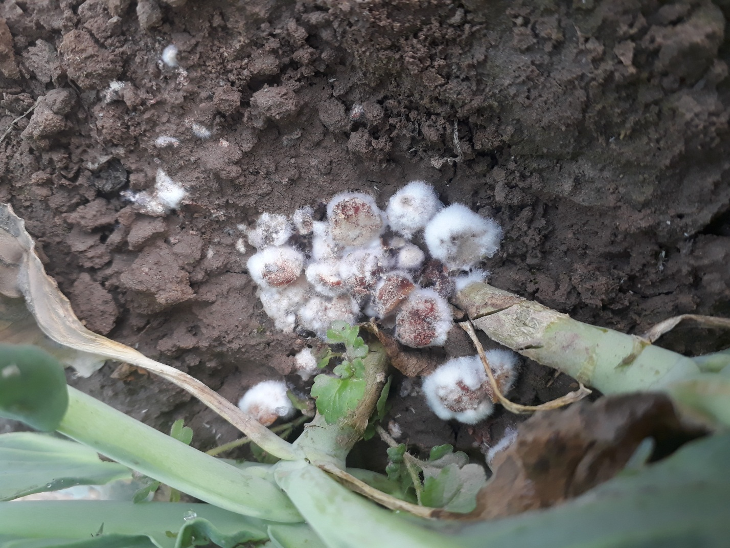
Fungal growth on chickpea placed in soil near stem for artificial inoculation as source scleritinia sclerotiorum.
Figure 5: Fungal growth on chickpea placed in soil near stem for artificial inoculation as source scleritinia sclerotiorum.
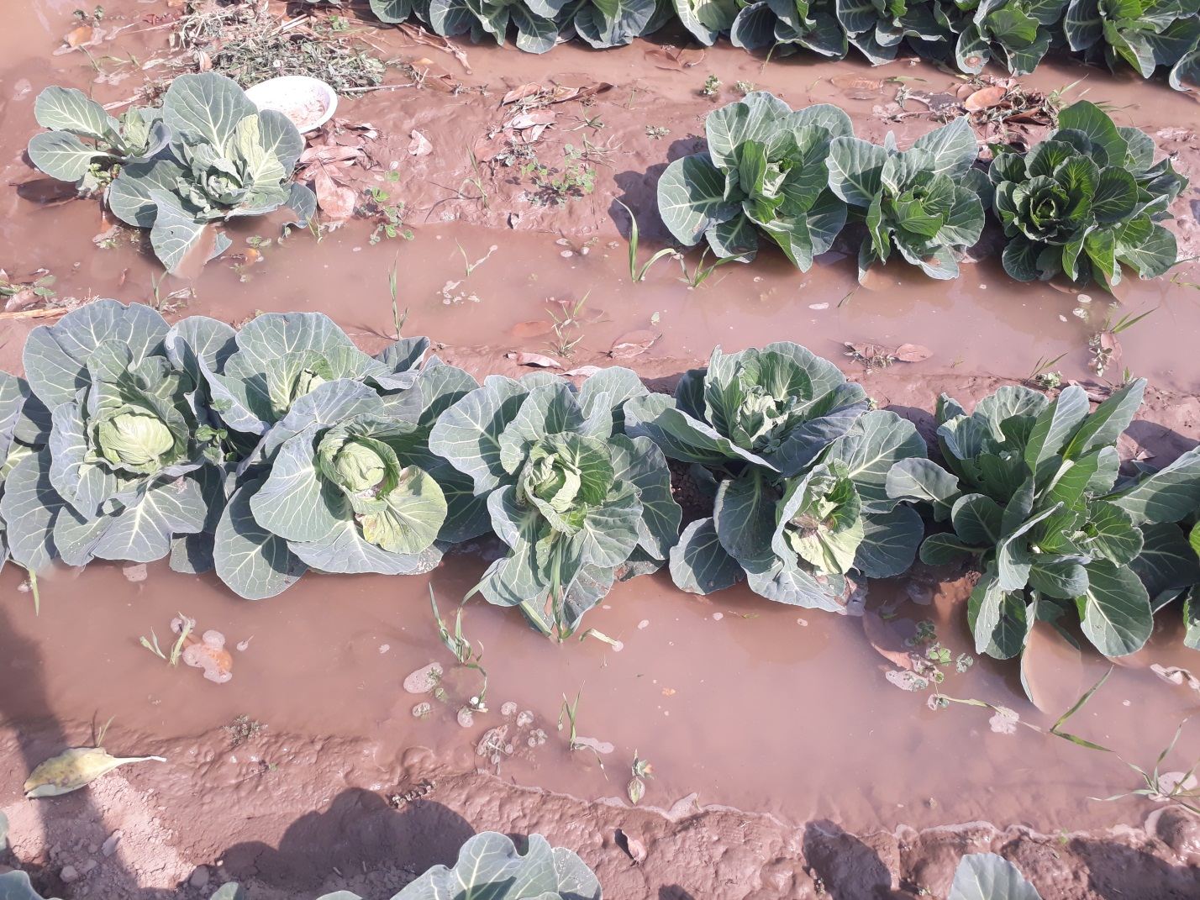
Figure 6: Cabbage planted at 5 inch rows, leaves dipped in the irrigation water promote fungal induction plants.
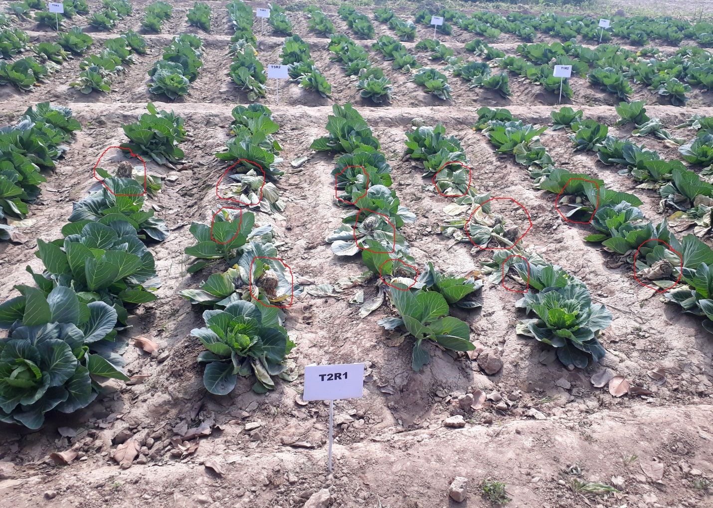
Figure 7: Foliar Application of Bio-Extracts and Fungicides in fiel. Circled plants show central leaves are drying due attack of s.sclerotiorum.

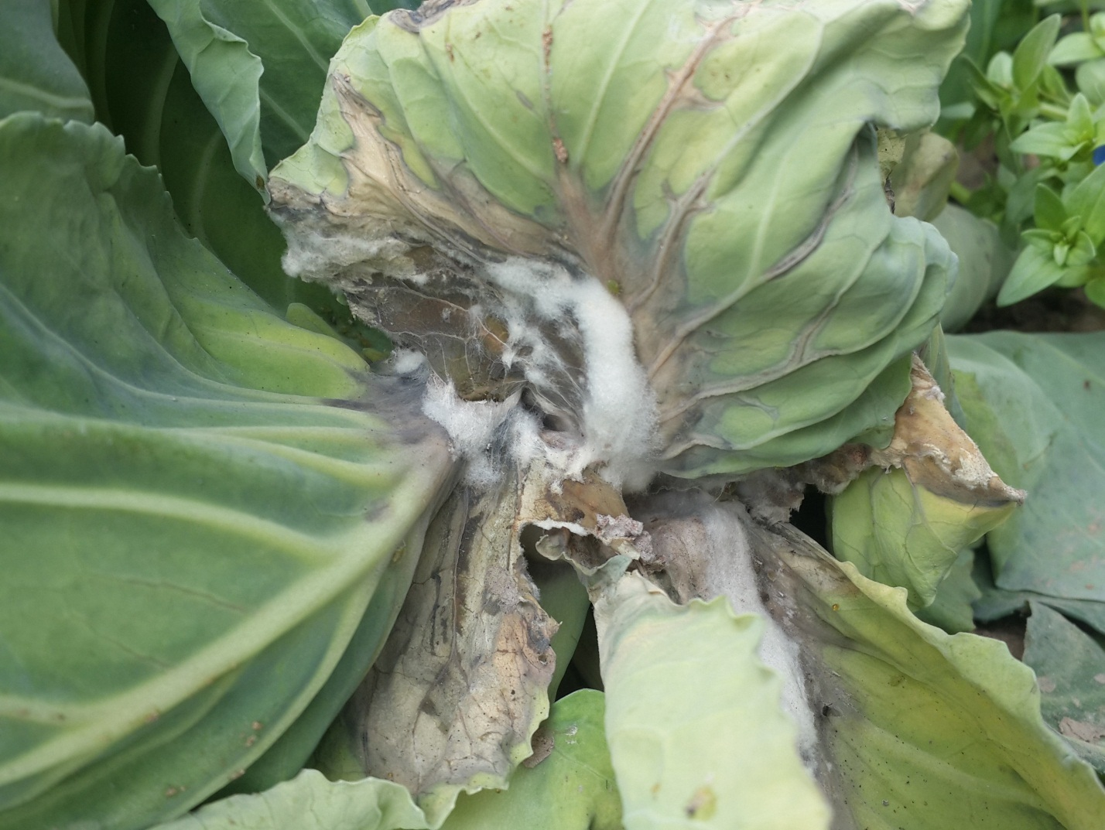
Figure 8: Initial stage of fungal attack on cabbage leaves progressing upward
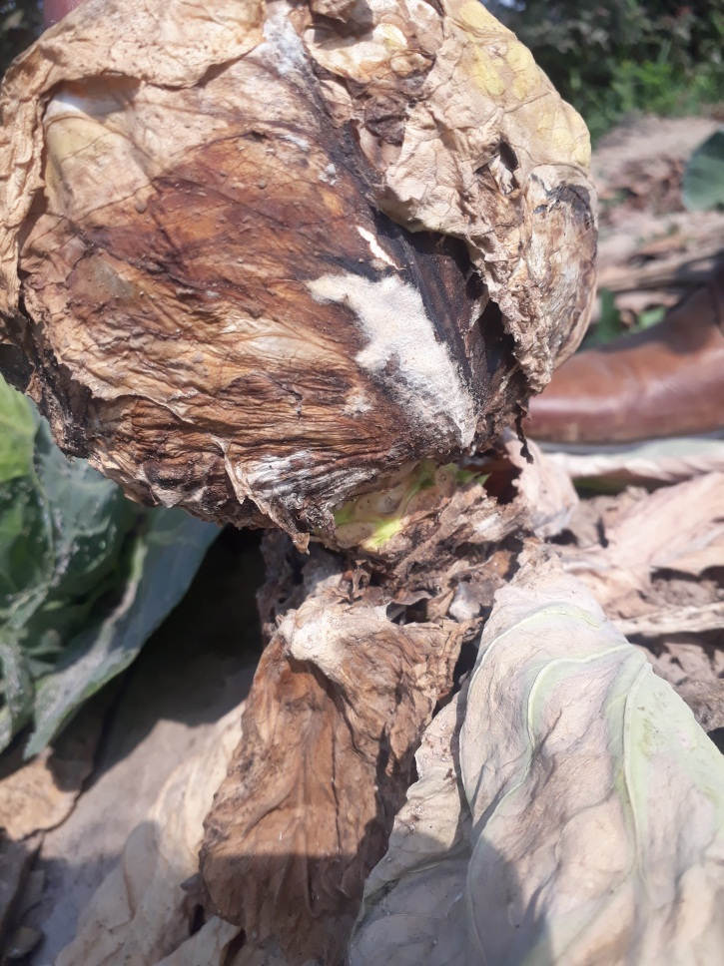
Figure 9: White cottony growth appear on attacked plant

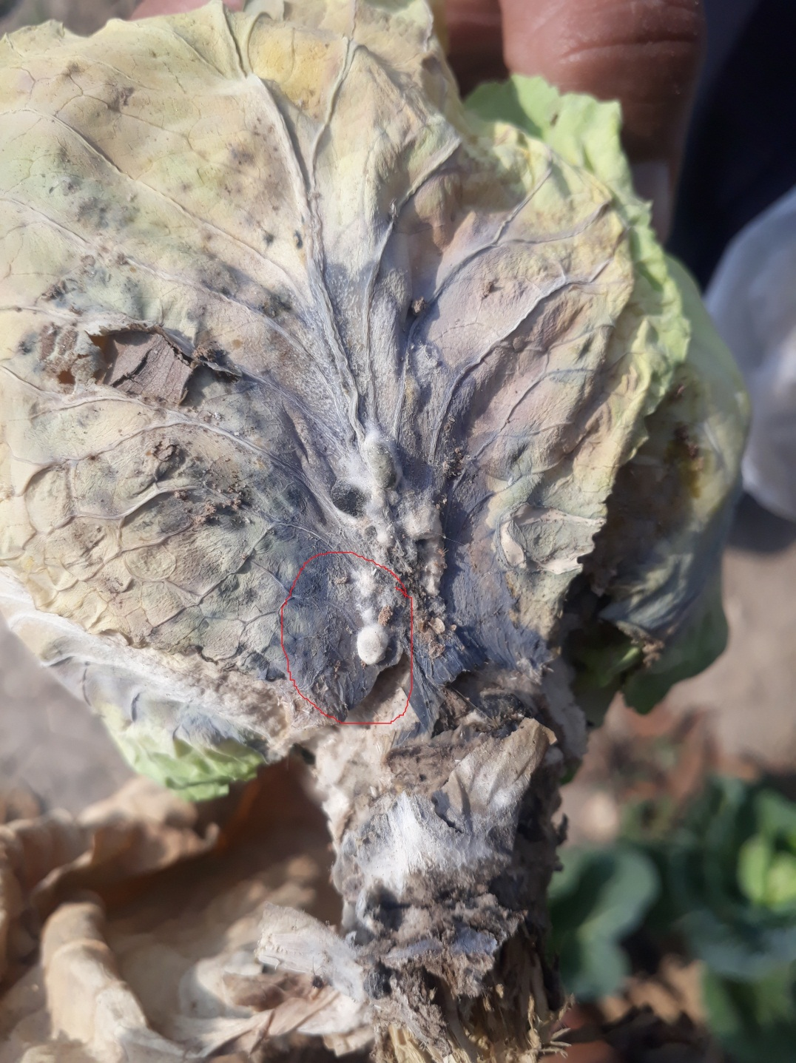
Figure 10: Leaves are Rotted and hard sclerotio have developed later they drop on ground and sporulate in next season.

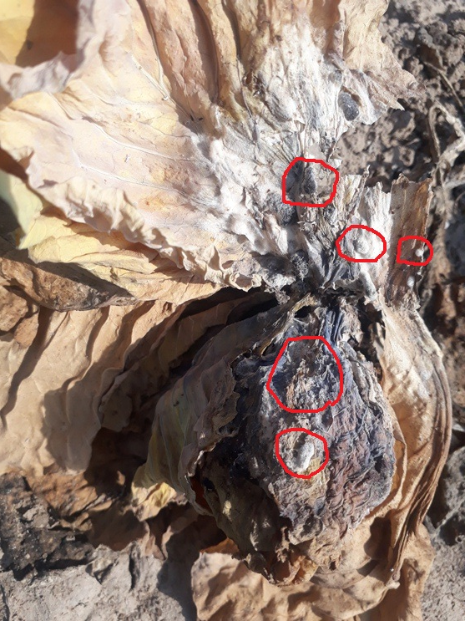
Figure 11: Cabbage leaves are completely rotted and sclerotio are developed in numbers ready to mixed in soil for survival.
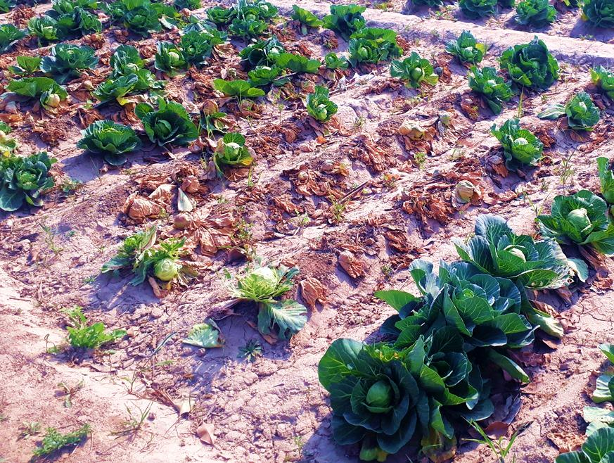
Figure 12: Incidence of disease in Foliar treatment of Neem extract.

