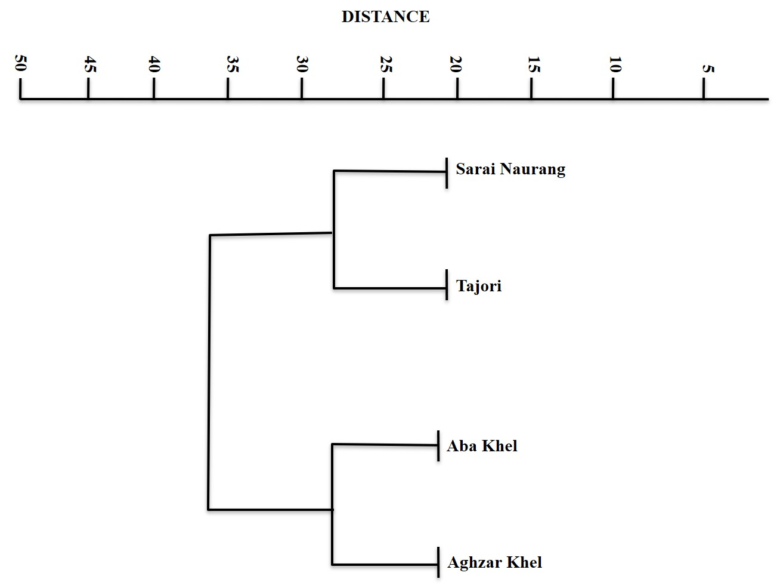

Figure 1. Dendogram resulting from the average linkage of 04 sites of District Lakki Marwat

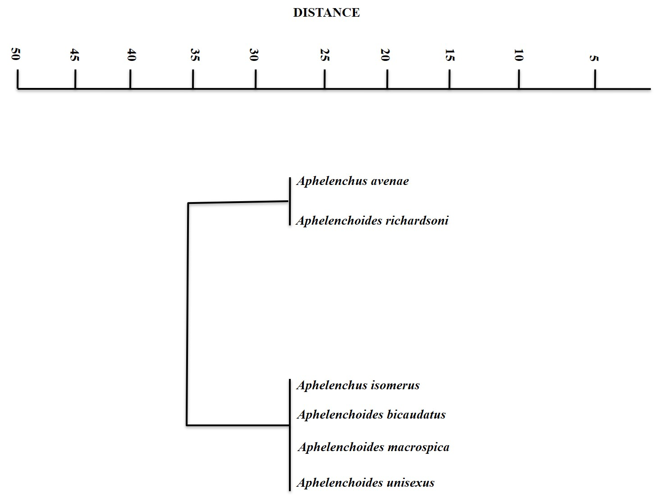

Figure 2. Dendogram resulting of cluster analysis of 06 species

Figure 3. Occurrence percentage of species

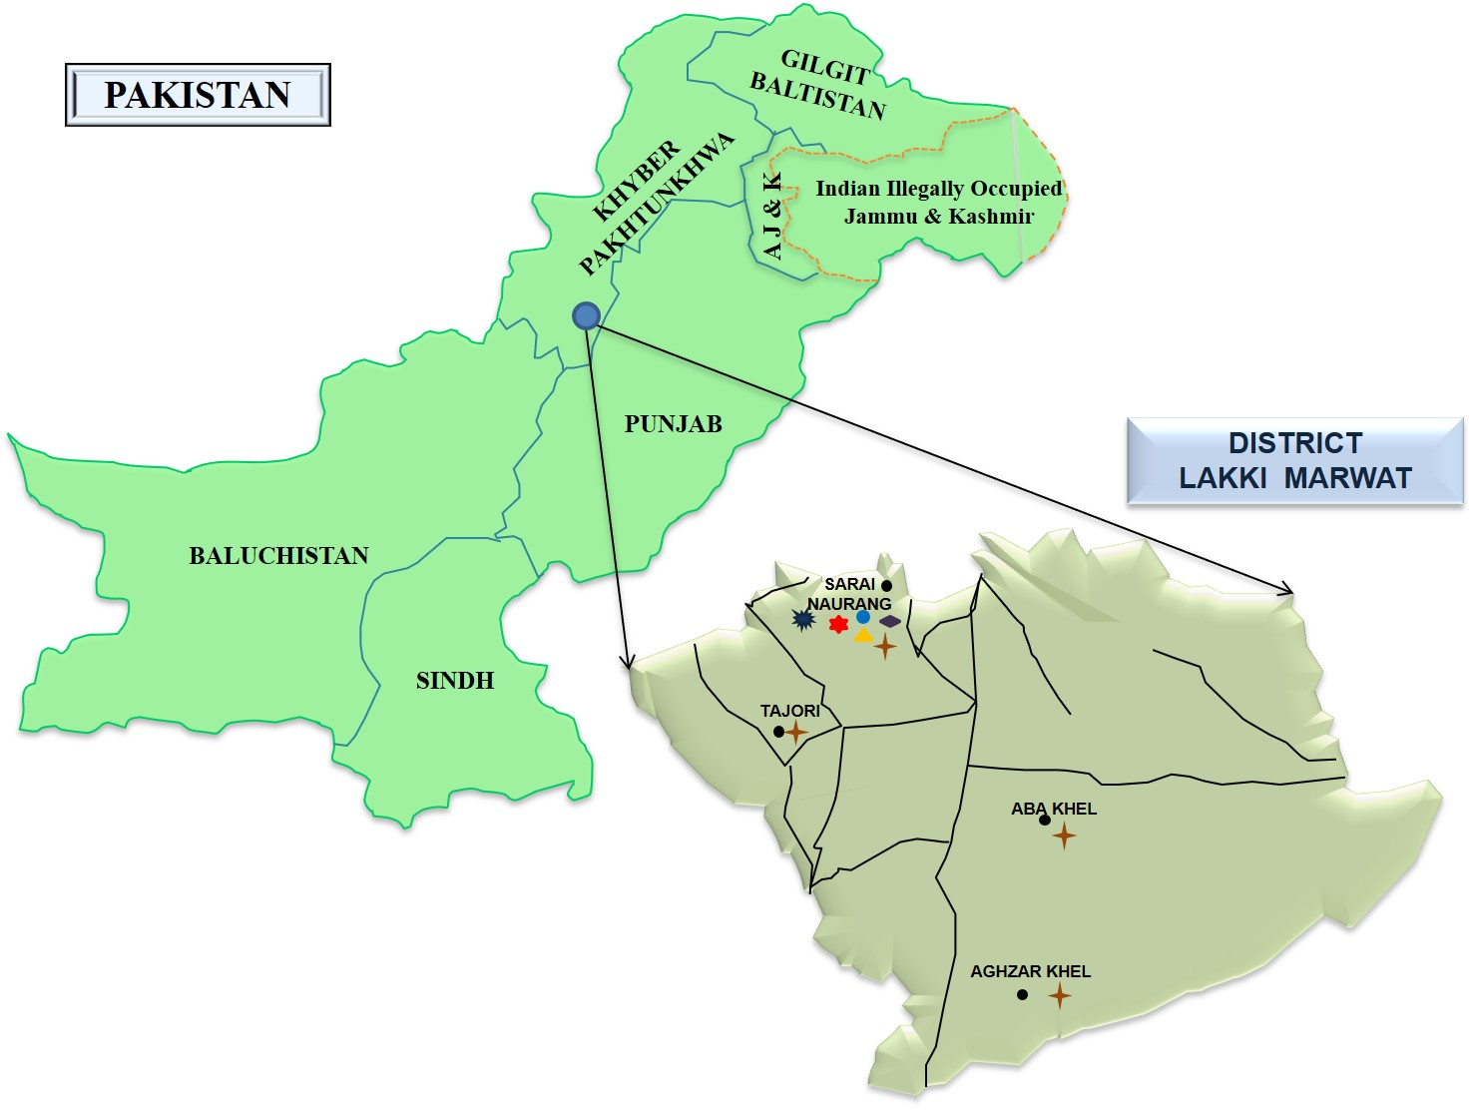

Figure 4. Species found from different locations of District Lakki Marwat, KPK, Pakistan

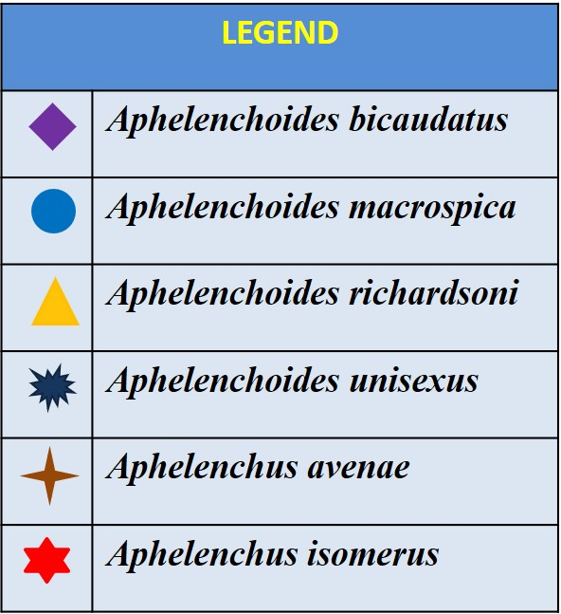

5
DISTANCE
10
15
20
25
30
35
40
45
50

Sarai Naurang

Tajori

Aba Khel

Aghzar Khel

Figure 1. Dendogram resulting from the average linkage of 04 sites of District Lakki Marwat

5
DISTANCE
10
15
20
25
30
35
40
45
50

Aphelenchus avenae

Aphelenchus isomerus
Aphelenchoides macrospica
Aphelenchoides richardsoni
Aphelenchoides unisexus
Aphelenchoides bicaudatus

Figure 2. Dendogram resulting of cluster analysis of 06 species

