DIAGNOSIS AND DETECTION OF MAIN PATHOGENIC FUNGUS OF ROOT ROT DISEASE ON DATE PALM OFFSHOOTS (Phoenix dactylifera L.), AND IN VITRO ANTAGONISM WITH Trichoderma harzianum
Naji Salim Jassim*¹ Mahmood Oda Jaafer²
1-Date palm research center- University of Basrah/ Basrah- Iraq
2- Department of plant protection/ College of Agriculture/ University of Basrah
Email of correspondence*¹: ahmidnaji916@gmail.com

ABSTRACT
Root rot is a significant underground disease in date palms(Phoenix dactylifera L.) and can be caused by a pathogenic soil-borne fungus, Fusarium oxysporum. Polymerase chain reaction (PCR) amplification was performed, followed by analysis of the sequences of nitrogen bases of the products using the program BLAST(Basic Local Alignment Search Tool). The results revealed that most pathogenic isolates were the fungi Fusarium oxysporum, Fusarium proliferatum S1, Fusarium proliferatum S2, and Fusarium fujikuroi. The selected isolates of Fusarium spp. were sequenced. The result of a pathogenicity assay shows that all the assayed isolated fungi were pathogenic to date palm plantlets at different percentages, and the main causative pathogenic fungus was F. oxysporum with disease severity (DS) of 96% and disease incidence (DI) of 96.6%. An attempt was made to find the most appropriate bioagents that can protect date palm offshoots (Phoenix dactylfera L.) from certain soil-borne fungal diseases. The antifungal efficacy of Trichoderma harzianum was tested in vitro, where it inhibited mycelial radial growth of F. oxysporum by 87% in PDA medium. The results showed there was no reduction in mycelial growth of T. harzianum at all the different concentrations of NaCl tested under in vitro growth conditions compared with control concentrations (0 dSm).
Key words: Date palm, Root rot disease, Fusarium oxysporum, Trichoderma harzianum.

INTRODUCTION
Date palm trees(Phoenix dactylifera L.) are susceptible to a variety of fungal pathogens that cause significant reductions in the number of trees and their production. Several soil-borne fungi attack date palms and have been recorded as causal pathogens of root rot, wilt, and declining diseases, such as Fusarium oxysporum, Fusarium solani, Fusarium moniliforume, Fusarium semitectatium, Thialoviopsis paradoxa, and Phomopsis phoenopsis (Djerbi,1983; Baraka et al., 2011).A good approach to controlling plant diseases requires a detailed understanding of the pathogens. However, there was been no on root rot infections of offshoots of date palm.The genus Fusarium is a global saprophyte soil fungus and includes several virulent phytopathogens (Dean et al., 2011). Strains of Fusarium spp. may become optional abiotrophic parasites under certain environmental conditions, triggering decay of the cortex, root rot, wilting, and eventually premature death(Coleman, 2016). Date palms trees are afflicted with a variety of soil-borne pathogenic fungi that pose a threat to adult trees and offshoots, causing significant tree damage and production losses globally (El-Morsi et al., 2009; Maitlo et al., 2013). The pathogenic fungal Fusarium oxysporum, Fusarium solani, Fusarium moniliform, and Rhizoctonia solani have been isolated from young offshoots and adults of the date palm (Phoenix dactylefera L.) in a number of sites (Alwahshi et al., 2019; Arafat et al., 2012; Baraka et al., 2011).Despite the significant economic losses caused by Fusarium oxysporum(Schlecht. emend. Synder & Hansen), the only way to combat the disease and reduce the significant economic losses is through disease prevention using systemic chemical fungicides and prophylactic treatments, both of which are severely limited(Chandel and Deepika, 2010). Fusarium oxysporum is a fungus that lives in the soil and has various invasion mechanisms. It attacks plants by inflicting natural sores on their roots, colonizes their vessels, and eventually kills the plant (Medeiros et al., 2012).
In conditions conducive to disease, such measures quickly become ineffective at regulating phytopathogens and pose serious environmental and health concerns. Recently, focus has been drawn to the quest for sustainable, healthy, and environmentally friendly alternatives to such measures. Biological control agents are living microorganisms that are used to prevent the development of plant pathogens(Pal and Gardener, 2006). However, few extensive scientific studies have been carried out on the successful protection of date palm trees against Fusarium spp. Several fungal biocontrol agents have been described and are available for use as beneficial organisms, such as Trichoderma spp, Aspergillus spp, Gliocladium spp, Candida spp, and Coniothyrium spp.(Naher et al., 2014).
The strains of the genus Trichoderma spp., are adaptable, expert root colonizers, global in nature, and quickly growing in culture. Also produce a large number of green conidia and chlamydospores, which are utilized for disease management in organic agriculture. Trichoderma spp., have all been employed with biological controls, biofertilizers, enzyme sources, protein makers, and prevention of plant disease infection (Harman,2000; Puyan,2016). Trichoderma strains improve the growth of root and shoots system area, as well as increases the dry and shoot weight of them(Yedidia et al. 2003).By using applications of Trichoderma in plants, can be avoided infection through induced plant resistance, competition for resources and space, antibiosis, and Mycoparasitism. Mycoparasitism the most significant direct antagonism mechanisms that targets between two fungus which results in the full lysis or death of one fungal propagules(Dix and Webster,1995; Maloy,1993).
Soil salinity inhibits not just plant growth and development, but also the growth of soil microorganism include fungi like Trichoderma spp.(Singh et al., 2019). Despite this, a number of salt-tolerant Trichoderma species have been reported. In salt-sensitive crops including rice, maize, wheat, tomato, and cucumber, the use of salt-tolerant Trichoderma spp. reduces the deleterious impacts of salinity(Ikarm et al., 2019; Zhang et al., 2019). The primary aim of this study was to isolate and identify the fungal pathogens that cause root rot infections on date palm offshoots, as well as in vitro testing of antagonism with the fungus T. harzianum.
MATERRIALS AND METHODS
Isolation of the associated fungi
Date palm offshoot (root) samples were collected from several nurseries in Basra Governorate, Iraq. The samples displayed signs and symptoms of yellowing and wilting and were taken for isolation. They were washed under tap water and then cut into segments (1 cm), which were sterilized by dipping in a 1% hypochloride solution for 2 minutes, followed by washing with sterile distilled water several times. The segments were dried on filter paper under growth chamber conditions and transferred separately to Petri dishes containing sterilized potato dextrose agar (PDA) medium. The Petri dishes were incubated at 25°C for 5–7 days, and then the colonies of fungal growth were isolated and purified using mycelial-growth, hyphal-apex, or single-spore methods. The fungi were classified according to morphological characteristics described by Booth(1985) and Sneh et al. (1991), and the appearance and frequency percentage of each fungus were calculated according to the following:
% Fungi appearance = [number of times each fungus appears/total number of samples] 100.
% Fungal Frequency = [Total number of isolates of each fungus/Total number of isolates] 100.
The fungal isolates obtained were kept on PDA slants and maintained at 5°C a refrigerator for future analysis.
DNA extraction, PCR amplification, and DNA sequencing
The partial ITS region of each Fusarium isolate’s DNA was extracted and amplified using polymerase chain reaction (PCR) and the universal primer pair ITS1 (5′-TCC GTA GGT GAA CCT GCG G-3ʹ) and ITS4 (5′-TCC TCC GCT TAT TGA TAT GC-3′) or EF1T (5′ -ATG GGT AAG GAA GAC AAG AC -3′) and EF2T (5′- GGA GGT ACC AGT GAT CAT GTT-3′) respectively (White et al., 1990). PCR amplification was performed using Taq DNA polymerase (Roche, Cat. No.11146173001) with a final volume of 20 µl. The PCR reaction mixture contained 2 μ1 of 10X PCR buffer, 1 μl of each primer (10 pmol), 2 μl of dNTPs (2 mM), 3 μl of DNA template (30 ng/μ1), and 1 unit of Taq polymerase. Each sample volume was adjusted to 20 μl by adding nuclease-free water. Primary denaturation at 94°C was performed for 1 minute, followed by 35 cycles of end denaturation at 94°C for 30 seconds, annealing at 55°C for 30 seconds, initial extension for 1 minute, and final extension at 72°C for 5 minutes. PCR amplification was carried out under the following conditions(Zhang et al.,2012). PCR-amplified products were electrophoretically separated under UV illumination on 1% agarose gel for 140 min at 80 V and 400 mA, stained with ethidium bromide, and imaged using a gel documentation method (Vilber Lourmat, Taiwan). For DNA sequencing, the PCR-amplified products were gel purified using a Favorprep PCR purification kit (Cat. No. FAGCK 001, Favorgen, Taiwan) and submitted to the Macrogen DNA sequencing service in Korea along with the primer pair (ITS1 and ITS4). The forward and reverse primers were used to directly sequence PCR results in both directions. Using the Basic Local Alignment Search Tool (BLAST), the acquired nucleotide sequences were aligned and compared to sequences from other isolates that had already been published in the National Centre for Biotechnology Information (NCBI). The nucleotide sequences were aligned several times, and MEGA 6 software was used to create phylogenetic trees using the neighbour-joining technique(Tamura et al., 2013).
Pathogenicity essay of fungi isolates
The capabilities of pathogenesis of isolated fungi were examined under the conditions of a greenhouse at the Date Palm Research Centre of Basra University in the season of 2019-2020. Plastic pots (30 cm in diameter) were sterilized with formalin solution (5%) for 10 minutes. Soil was sterilized with formalin solution (5%) for 7 days and then dried for 2 weeks until the formaldehyde dissipated. The sterilized pots were filled with sterilized soil (5 kg/pot).An autoclaved millet grain medium was used to grow the tested fungi in 500-mL glasses. The inoculation was performed with discs (0.5 cm in diameter) taken from 7-day-old colonies of each examined fungal isolate, and all glasses were incubated for 15 days at 27±1°C with shaking every 48 hours. At 5% of the soil weight, the sterilized soil was separately inoculated with fungi carried on millet grains. Before planting, the pots were watered three times weekly to ensure that the fungus inoculum was evenly distributed in the soil. In each pot, three date palm plantlets (10 months old) were grown, and five pots were used as replicates. Four pots filled with non-infested soil were cultivated and used as controls. Three months after pot planting, the incidence and severity percentages of disease were recorded. The pathogen was reisolated from plants that showed symptoms of disease and contrasted with the initial culture used. Foliage signs were recorded and assessed on a scale of 0–4 according to the percentage of vegetation affected: 0 = healthy, 1 = less than 25% diseased foliage (symptoms are mild); 2 = 26–50% diseased foliage (symptoms are moderate); 3 = 51–75% diseased foliage (severe symptoms); 4 = over 76% diseased foliage (transplants are dead or near death). The format of Liu et al. (1995) was used to calculate the disease severity (DS) as DS = d/ (dmax n) = 100, where d is the disease ratio of each transplant, dmax is the maximum disease rating, and n is the total number of assayed transplants in each replication.
In vitro antagonistic assay
An experiment was performed to examine the antagonistic relationship between the pathogenic fungus Fusarium oxysporum and the biological agent Trichoderma harzianum. F. oxysporum was identified using molecular methods focused on sequencing amplification products of the ITS regions by PCR with accession number MK751702.1. The relationship was examined using the technique of dual culture described by Garrett(1956) with a few modifications. The bio agent fungus T. harzianum was isolated and purified by BioHealth WSG Administration and Distribution (Humintech GmbH, Heerdter LandstraBe189/D*D40549Dusseldorf/GermanyE-Mail: info@humintech.com; Internet: www.humintech.com). Discs (0.5 cm in diameter) from mycelial plugs were cut using a cork borer from active culture plates of both F. oxysporum and T. harzianum and placed on opposite sides in a Petri dish containing sterilized PDA at a distance of 3 cm from each other. The Petri dishes were incubated at 27ºC. In control treatments, a disc of F. oxysporum (0.5 cm) was placed in a dish containing sterile PDA. The mycelial growth was recorded after 48, 72, and 96 hours, and the inhibition percentage was measured. The experiment was done in five replicates, and the inhibition percentage of radial growth was calculated as:
% Inhibition = [ (C–T)/C] 100, where C is the radial growth of the control colony, and T is the radial growth of the pathogen colony with antagonism in dual culture(Garret,1956).
Tolerance assay of Trichoderma harzainum in PDA with various concentrations of NaCl
T. harzainum was cultured at 25 C for 5 days in PDA. Mycelium discs (0.5 cm) were obtained from the colony edge of the PDA plates and inoculated into new PDA, amended with various concentrations of NaCl (0, 10, 15, 18, 21, 24, 27, and 30 dSm-1). The plates were incubated at 25 C. The diameters of the colonies were measured daily during culturing. Each concentration (treatment) contains five replicates. The salt tolerance ability of T.harzainum isolates was evaluated as the percentage inhibition of mycelial growth(IMG) calculated by:
%IMG = (C-N) 100/C, where N = radial mycelial growth on PDA with NaCl, and C = radial mycelial growth on NaCl-free medium (0 dSm⁻¹).
STATISTICAL ANALYSIS
Analysis of variance was conducted using MSTAT-C software version 2.10 (1991). The least significant difference (LSD) was estimated at p ≤ 0.05.
RESULTS
Percentage of appearance and frequency of the isolated fungi
The most of fungal isolates were identified based on descriptions of colony morphology, conidiophores, and conidia(Fig.1).The data in Table (1) show that the pathogenic fungus Fusarium oxysporum had the highest percentage of appearance and frequency, reaching 100% and 41.46%, respectively. In contrast, the lowest percentages of appearance and frequency of isolation were recorded for Thielaviopsis paradoxa (39 and 7.3%, respectively).
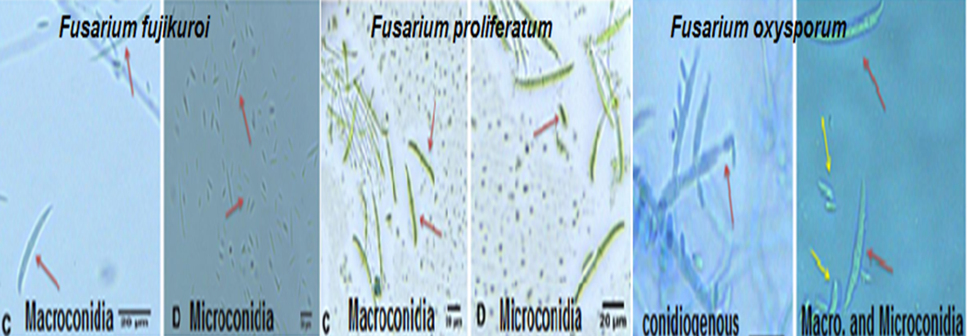
Fig. 1 The descriptions of colony morphology, conidiophores, and conidia of the most isolated pathogenic fungi(Fusarium oxysporum, F. proleferatum, F. fujikuroi)
Pathogenicity assays
The results of isolation experiments from the infected samples of date palm offshoots showed that the fungi Fusarium oxysporum, F. proliferatum S1, F. proliferatum S2, F. fujikuroi, and T. paradoxa were the main causal pathogens in date palm offshoots growing in the Basra Governorate. These infected offshoots showed exemplary symptoms of root rot and wilt diseases. Data in Table 2 show that all the isolates of assayed fungi were pathogenic to inoculated plantlets. Isolates of pathogenic fungi slightly differed in their capability of establishing disease and the appearance of disease symptoms. The pathogenic fungus Fusarium oxysporum had the highest disease rating and disease severity (DS) of the percentage of root rot of date palms (4–96%), followed by F. proliferatum S1 (3–37%) and F. proliferatum S2(3–31%). Similarly, F. oxysporum caused a high incidence of root rot symptoms on date palm plants (66.66%). However, T. paradoxa showed the lowest disease severity of 8.33% for root rot diseases and had a disease rating scale of 2.
The morphological symptoms seen in figures 1 and 2 are typically highly obvious on date palm offshoots.
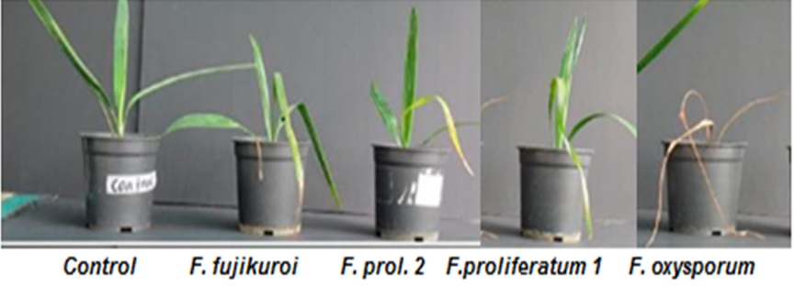
Fig. 2 Typical symptoms of the root rot disease on date palm offshoots treated with pathogenic fungi isolates and control.
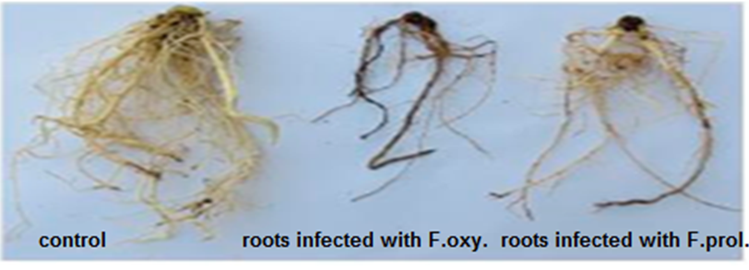
Fig. 3 Typical symptoms of the root rot disease on the roots of date palm offshoots.
Molecular identification of the fungal pathogen
The results showed that the identified isolates belong to the fungi Fusarium oxysporum, F. proliferatum S1, F. proliferatum S2, and F. fujikuroi. The sequences of nitrogen bases obtained from the identified fungal isolates were compared with those available at the NCBI. The identified sequences of these fungi have been deposited in the GenBank database (NCBI) with PCR amplification and nucleotide sequencing of the ITS region of fungal isolates: MK751702.1 for F. oxysporum; LT970774.1 for F. proliferatum S1; KX582247.1 for F. proliferatum S2; and KY29366.1 for F. fujikuroi (run ends: 20/4/2019). The figure (2) describes the DNA products amplified by polymerase chain reaction(PCR)from Fusarium isolates (Fusarium oxysporum (10), F. proliferatum S1(1), F. proliferatum S2 (2), and F. fujikuroi (13)).
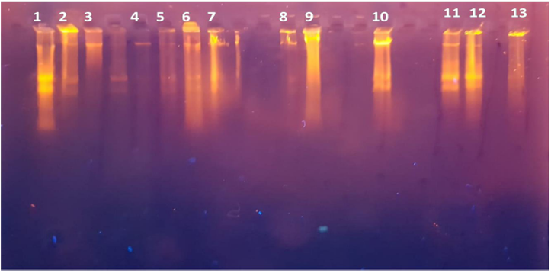
Fig. 4 DNA products amplified by polymerase chain reaction (PCR) from Fusarium isolates (Fusarium oxysporum (10),F. proliferatum S1(1),F. proliferatum S2 (2),and F. fujikuroi (13).
In vitro antagonistic assay
The in vitro experiment was carried out based on the biological evidence obtained thus far to gain the best understanding of the ability of competition and biocontrol capacity of T. harzianum against F. oxysporum. In dual-culture tests on Petri dishes, T. harzianum quickly stopped the mycelial growth of the fungus pathogen F. oxysporum and fully covered the colony of F. oxysporum. T. harzianum showed faster mycelial growth than F. oxysporum, and a wide area of the culture medium was colonized (Fig. 5 A). A thin pre-contact zone of growth inhibition for T. harzianum could be observed for several hours just prior to physical contact between hyphae after 48 hours of growth. This initial partnership between F. oxysporum and T. harzianum can include both defensive and offensive fighting by both species. This shows that their interaction is possibly related to the production of inhibitory organic compounds like diffusible and non-volatile compounds. Such secondary metabolites or antibiotics can be introduced with the activity of cell metabolism correlating to development and expansion at a short distance. However, it can be fairly hypothesized that T. harzianum is able to detoxify them easily. Indeed, the hyphal development of F. oxysporum definitively stopped and reached an occupancy of 65% relative to the control (Fig. 5 B). After this short 72-hour period of incubation with cross-signalling by pre-contact chemical dialog, T. harzianum was able to invade the inhibition zone and interfere with the colony of F. oxysporum between. Furthermore, after 96 hours, T. harzianum quickly showed intense sporulation at various points of its hyphal expansion, including the colony of F. oxysporum (Fig. 5 C).

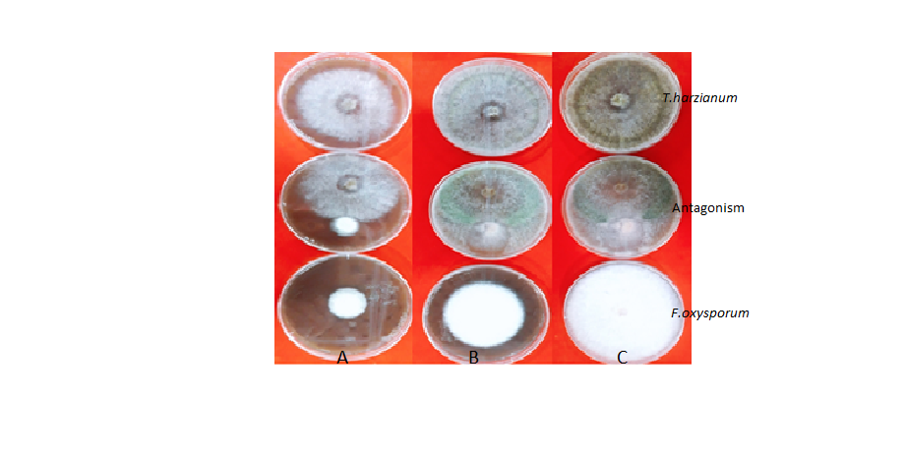

Fig. 5 Antagonistic potential of T. harzianum isolate against F. oxysporum in dual culture at different periods of time on potato dextrose agar (PDA) medium. A: After 48 hours, B: After 72 hours, and C: After 96 hours of antagonism (each culture plate represents the mean of four replicates for each treatment).
Effects of various NaCl concentrations on colony growth of T. harzianum isolates
It is mandatory to assay the T. harzianum isolate's ability to tolerate different NaCl concentrations as a prerequisite before the application of this isolation in saline areas with the plants to improve their physiological properties. In Figure (6), the results obtained from the mycelial growth of T. harzainum are shown at different NaCl concentrations. As expected, there was no inhibition of mycelial growth at all the different NaCl concentrations tested under in vitro growth conditions compared with control (0 dSm).

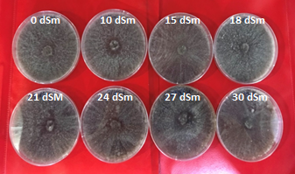
Fig. 6 The Effect of different concentrations of NaCl on the radial mycelial growth of the fungus T.harzianum on PDA medium at 28 C in the laboratory (Each culture plate represents the mean of four replicates for each treatment).
DISCUSSION
Percentage of appearance and frequency of isolated fungi
F. oxysporum is a significant and diverse phytopathogenic fungus that infects approximately 150 plant species through a variety of infection methods. Fusarium species can be found as parasites, endophytes, or saprophytes on plants, in soil, and in water in both agricultural and natural settings (O’Donnell et al., 2000). Consistent with other studies, the results of our study showed that the root rot disease of the date palm is caused by various pathogenic fungi, such as F. oxysporium, F. ptoliteratum, F. fujikuroi, F. moniliform, T. paradoxa, and Rhizoctonia solani (Abedalrad, 2019; Ahmed, 2018).
Pathogenicity assays
The pathogen variations observed may be related to date palm roots producing various exudates that cause an increase in the number of saprophyta fungi around the roots, which are affected by soil-borne fungal pathogens(Xue et al., 2011). The ability of the fungus pathogen Fusarium oxysporum to cause disease in the plant is related to many mechanisms by which the pathogen works, such as the production of types of mycotoxins like trichothecene, fusaric acid, and enzymes, such as cell wall enzymes. A few virulence factors also degrade many metabolic compounds produced inside the host plant or pathogenic factors related to a specific feature function, such as siderophores, amino acids, and osmolites(Rana et al., 2017). In all Fusarium genomes, the genes that encode for the enzymes that degrade cell walls and hydrolytic enzymes are important in enhancing access to nutrients during infection(IIgen et al., 2008). According to our findings, the most pathogenic fungi were F. oxysporum, F. proliferatum, F. fujikuroi, F. moniliforme, and T. paradoxa, which were responsible for the incidence of root rot diseases in date palms. These findings are consistent with those of Ahmed (2018) who discovered Fusarium spp. when isolating fungi from date palm roots. Also, El-Morsi et al.(2015) showed that F. oxysporum was the major pathogenic fungus when they measured percentage root rot/wilt severity (89.26%), followed by F. solani and F. moniliforme, which caused 82.18% and 73.26% disease severity, respectively.
Molecular identification of the fungal pathogen
Although the use of characteristics can lead to accurate results on occasion, many researchers do not rely on them because they require extensive experience in the subject of categorization, especially when dealing with fungus groupings that are closely related, such as Fusarium spp. Identification at the genome level by PCR has led to precision, sensitivity, and the ability to classify genetic variations and remove the drawbacks of traditional approaches in the identification of many species (Abedelrad, 2019; Stanis et al.,2016).
In vitro antagonistic assay
Many mechanisms of action have been identified in the Trichoderma genus in relation to their ability to act as biocontrol agents against fungi. This antagonist may result in mycoparasitism, antibiosis, competition for nutrients and space, and cell-wall degrading enzymes(Kumar,2013). Furthermore, the findings observed may be caused by different pathogens having distinct defence mechanisms against enzymes and toxic substances produced by various bioagents (Ahmed, 2013). Trichoderma secretes certain chemical metabolites that may be responsible for their inhibitory or antagonistic action in vitro, such as phenols, steroids, flavonoids, quinines, terpenoids, peptides, cytocatalasins, alkaloids, and phenylpropanoids(Ghorbanpour et al., 2018; Mausam et al., 2007). In addition, through mycoparasitism, Trichoderma spp. mycopathogens antagonize other fungi as they weaken their cell walls by developing lytic enzymes such as chitinases, peroxidases, and glucan 1-3 B-glucosidases (Ahmed, 2013; Muthu et al., 2006; Sood et al.,2020).The ability to develop quickly gives the antagonist a significant advantage over other fungi in terms of space competition, nutrients, and outperformance, all of which are equally significant phenomena with shared inclusion(Benitez et al.,2004).Our finding of antagonism inhibiting growth is consistent with the findings of Rudresh et al.(2005), who discovered that T. harzianum and T. viride inhibited the growth in vitro of two pathogens, R. solani and F. oxysporum, by 72.1 and 77.0%, respectively. This was achieved by producing antifungal metabolism and strong mycoparasitic activity due to completely overgrowing the competing mycelia.
Effects of salinity on colony growth of T.harzianum isolate
Soil microbial communities have an important role in food cycling, organic matter volume, and plant productivity. According to Zahran (1997), filamentous fungi are extremely resistant to hydric stress and the increased pressure of osmotic stress and may change their physiology and appearance as a result. Killham (1994) described two microorganism adaptation methods to osmotic stress. Both result in the assembling of solutes in the cell to counterbalance the increment in osmotic pressure and the selective prevention of the amalgamated solutes (Na, Cl⁻), resulting in the accumulation of the ions required for metabolism. Our findings are consistent with those of Kumar et al. (2016), who examined the tolerance of 70 Trichoderma spp. isolates to various NaCl concentrations. The results revealed that 92.8% (65) of the isolates could withstand a NaCl concentration of 5%. While 45.7% (32) of the isolates were able to withstand 10% of the NaCl concentration when the concentration was increased further. Poosapati et al., (2014), found that all the tested Trichoderma isolates were significantly tolerant with the highest mean colony growth at all saline concentration rates except the 1M NaCl concentrate, which had a 65-70% reduction in colony growth.
CONCLUSION
PCR was used in this analysis to diagnose Fusarium spp. isolates because of its high precision in the diagnosis of many species, which was useful for detecting F. oxysporum in infected date palm offshoots quickly, sensitively, and consistently. The pathogenicity test of the fungal isolates found that the pathogenic fungus F. oxysporum had the highest disease severity(DS) and disease incidence(DI) in cases of root rot of date palm. In vitro, the findings of T. harzianum antagonism showed the greatest percentage of mycelial growth suppression of F. oxysporum. Nevertheless, a more comprehensive study is needed to confirm the potential of these organisms for the biological control of pathogenic fungi and regulating plant growth, which may be beneficial in the future as a biological agent.
Funding: No funding
Conflict of interest: Authors declare no conflict of interest.
Ethical approval: This article does not contain any studies with human participants or animals performed by the author

REFERENCES
Abedalred, E.M., W.M. Ismail1, R.G. Abdulmoohsin and M.A.J. Al-Karhi. 2019. First molecular identification of Fusarium fujikuroi causing pollen rot of palm trees(Phoenix dactylifera L.) in Iraq and evaluation efficacy of some nanoparticles against it. International Conference on Agricultural Sciences IOP Conf. Series: Earth and Environmental Science 388. doi:10.1088/1755-1315/388/1/012007.
Ahmed, M.F.A. 2018. Management of date palm root rot diseases by using some biological control agents under organic farming system. Novel Research in Microbiology Journal, 2(2): 37-˗ 47.
Ahmed, M.F.A. 2013) Studies on non-chemical methods to control some soil borne fungal diseases of bean plants Phaseolus vulgaris L. Ph.D. Thesis. Faculty of Agriculture, Cairo University.137pp.
Alwahshi. K.J., E.I. Saeed, A.Sham, A.A. lblooshi, M.M. Alblooshi, K.A. El-Tarabily and S.F. AbuQamar. 2019.Molecular identification and disease management of date palm
sudden decline syndrome in the United Arab Emirates. International Journal of Molecular Sciences, 20: 923. https:// doi.org/10.3390/ijms20040923
Arafat, K.H., A.M. Mohamad and S. Elsharabasy. 2012. Biological control of date palm root-rots diseases using Egyptian isolates of Streptomyces. Research Journal of Agriculture and Biological Sciences, 8(2):224–230.
Baraka, M.A., F.M. Radwan and K.H. Arafat. 2011. Survey and identification of major fungi causing root rot on date palm and their relative importance in Egypt. Journal of Biological and Environmental 6(2): 319-˗337. www.acepsag.org.
Benitez, T., A.M. Rincon, M.C. Limon and A.C. Codon. 2004. Biocontrol mechanisms of Trichoderma strains. International of Microbiology. 7: 249-˗260.
Booth, C. 1985. The genus Fusarium. Common Wealth Mycological Institute, pp. 237.
Chandel, S. and R. Deepika. 2010. Recent advances in management and control of Fusarium yellows in Gladiolus species. Journal of Fruit Ornamental Plant Research. 18: 361–380.
Coleman, J.J. 2016.The Fusarium solani species complex: ubiquitous pathogens of agricultural importance. Mol. Plant Pathology. 17:146–158. doi: 10.1111/mpp.12289.
Dean, R., J.A.L. Van Kan, Z.A. Pretorius, K.E. Hammond-Kosack, A. Di Pietro, P.D. Spanu et al. 2012.The Top 10 fungal pathogens in molecular plant pathology. Molecular of Plant Pathology. 13: 414–430.
Djerbi, M. 1983. Diseases of the Date Palm (Phoenix dactylifera L.). Near East and North Africa, FAO Regional Project for Palm and Dates Research Centre. p. 106.
Dix, N.J. and J. Webster. 1995. Fungal Ecology. 1st ed. London: Chapman and Hall.
EL-Morsi, M.E.A., M.F. Abdel-Monaim and E.F.S. Ahmad. 2015. Management of root rot and wilt diseases of date palm offshoots using certain biological control agents and its effect on growth parameters in the New Valley Governorate, Egypt. Journal of Phytopathology and Pest Management. 2(1): 1-˗11.
Garrett, S.D.1956. Biology of root-infecting fungi. Cambridge Univ. Press, New York, p 293.
Harman, G.E. 2000. Myths and dogmas of Bio control: Changes in the perceptions derived from research on Trichoderma harzianum T-22. Plant Diseases. 84:377-393
Ikrama, M., N. Alia, G. Janb, A. Iqbal, M. Hamayunb, F. Gul, A. Hussainb and J. Leed. 2019. Trichoderma reesei improved the nutrition status of wheat crop under salt stress. Journal of plant interaction. 14(1):590-˗ 602. doi.org/10.1080/17429145.2019.1684582
Ilgen, P., F. Maier and W. Schäfer. 2008. Trichothecenes and lipases are host-induced and secreted virulence factors of Fusarium graminearum. Cereal Research Communications. 36:421-˗428.
Killham, K. 1994. Soil Ecology (1), Cambridge University Press, ISBN: 0 521 43521 8, United Kingdom.
Kumar K., K. Manigundan and N. Amaresan. 2016. Influence of salt tolerant Trichoderma spp. on growth of maize (Zea mays) under different salinity conditions. Journal of basic microbiology. 56:1-˗10.
Kumar, S. 2013. Trichoderma: a biological control weapon for managing plant diseases and promoting sustainability. International Journal of Agricultural Sciences and Veterinary Medicine. 1 (3):106–121.
Liu, L., J.W. Kloepper and S. Tuzun. 1995. Introduction of systemic resistance in cucumber against Fusarium wilt by plant growth-promoting rhizobacteria. Phytopath. 85: 695–698.
Maloy, O.C. 1993. Plant Disease Control: Principles and Practice. New York: John Wiley Sons Inc.; p. 346
Maitlo, W.A., G.S. Markhand, A. Abul-Soad, A.M. Lodhi and M.A. Jatoi. 2013.Chemical control of sudden decline disease of date palm (Phoenix dactylifera L.) in Sindh, Pakistan. Pakistan Journal of Botany, 45:7–11.
Mausam, V., S. Brar, R. Tyagi, R. Surampalli and J. Valero. 2007. Antagonistic fungi, Trichoderma spp.: Panoply of biological control. Biochemical Engineering Journal. 37(1):1-˗20.
Medeiros, D., G. Marcelino, D. Albuquerque, A. Viana and K. Silva. 2012. Ethanolic extract of Senna alata in control of Fusarium oxysporum responsible for fusarium wilt in melon R. Bras. Eng. Agríc. Ambiental,16(11): 1166-1170.
Muthu, C., M. Ayyanar, N. Raja and S. Ignacimuthu. 2006. Medicinal plants used by traditional healers in Kanchipuram district of Tamil Nadu, India. Journal of Ethnobiology and Ethnomedicine. 2:43.
Naher L, U.Yusuf, A. Ismail and K. Hossain. 2014. Trichoderma spp Abiocontrol agent for sustainable management of plant diseases. Pakistan Journal of Botany 46(4):1489-˗1493.
O’Donnell, K., H.C. Kistler, B.K. Tacke and H.H. Casper. 2000. Gene genealogies reveal global phylogeographic structure and reproductive isolation among lineages of Fusarium graminearum, the fungus causing wheat scab. Proc Nat Acad Sci USA 95:7905–7910.
Pal, K.K. and B.M. Gardener. 2006. Biological Control of Plant Pathogens. The Plant Health Instructor.
Poosapati, S., P.D. Ravulapalli, N. Tippirishetty, D.K. Vishwanathaswamy and S. Chunduri. 2014. Selection of high temperature and salinity tolerant Trichoderma isolates with antagonistic activity against Sclerotium rolfsii. Springer Plus. 3: 641.
Puyam, A. 2016. Advent of Trichoderma as a bio-control agent. A Review Journal of Applied and Natural Science.8(2):1100-1109
Rana, A., M. Sahgal and B.N. Johri. 2017. Fusarium oxysporum: Genomics, Diversity and Plant–Host Interaction. Developments in Fungal Biology and Applied Mycology. p:159–199 https://doi.org/10.1007/978-981-10-4768-8_10
Rudresh, D.L., M.K. Shivaprakash, and R.D. Prasad. 2005. Effect of combined application of Rhizobium, phosphate solubilizing bacterium and Trichoderma spp. on growth, nutrient uptake and yield of chickpea (Cicer arietinum L.). Applied Soil Ecology. 28:139-˗146.
Singh, V., C. Keswani, S. Ray, R.S. Upadhyay, D.P. Singh, R. Prabha, B.K. Sarma and H.B. Singh. 2019. Isolation and screening of high salinity tolerant Trichoderma spp. with plant growth property and antagonistic activity against various soilborne phytopathogens. Arch. Phytopathology and Plant Protection. 52:667–680
Sneh, B., L. Burpee and A. Ogoshi. 1991. Identification of Rhizoctonia species. APS Press, St. Paul, MN, USA, 133 pp.
Sood, M. D. Kapoor, V. Kumar, M.S. Sheteiwy, M. Ramakrishnan, M. Landi, F. Araniti and A. Sharma. 2020. Trichoderma: The “secrets”of a multitalented biocontrol agent. Plants 9:762.
Stanis, C.S., B.K. Song, T.H. Chua, Y.L. Lau and J. Jelip. 2016. Evaluation of new multiplex PCR primers for the identification of Plasmodium species found in Sabah. Turkish Journal of Medical Sciences. 46: 207-˗218.
Tamura, K., G. Stecher, D. Peterson, A. Filipski and S. Kumar. 2013. MEGA6:Molecular evolutionary genetics analysis version 6. Molecular Biology and Evolution. 30(12):2725-˗2729. DOI: 10.1093/molbev/mst197.
White, T.J., T. Bruns, S. Lee and J.W. Taylor. 1990. Amplification and direct sequencing of fungal ribosomal RNA genes for phylogenetics, p.315-˗ 322. In M. A. Innis, D. H. Gelfand, J. J. Sninsky, and T. J. White (ed.), PCR protocols: a guide to methods and applications. Academic Press, Inc; New York, N.Y.
Xue Jing, W., J. Yong Sheng, L. Wei, T. BaoSheng and W. You Nian. 2011. Identification and inhibitory effects of antagonistic bacteria against strawberry root rot (Fusarium oxysporum). Acta Horticulturae Sinica. 38:1657-˗1666.
Yedidia, I., M. Shoresh, Z. Kerem, N. Benhamou, Y. Kapulnik and I. Chet. 2003. Concomitant induction of systemic resistance to Pseudomonas syringae pv. Lachrymans in cucumber by Trichoderma sperellum(T203) and accumulation of phytoalexins. Appliedand Environmental Microbiology.69:7343-7353
Zahran, Z . 1997. Diversity, adaptation and activity of the bacterial flora in saline environments. Biology and Fertility of Soils. 25( 3): 211– 223
Zhang, F., Y. Wang, C. Liu, F. Chen, H. Ge, F. Tian, T. Yang, T and et al. 2019. Trichoderma harzianum mitigates salt stress in cucumber via multiple responses. Ecotoxicology Environmental Safety. 170: 436–445.
Zhang, S., X. Zhao, Y. Wang, J. Li, X. Chen, A. Wang and J. Li. 2012. Molecular detection of Fusarium oxysporum in the infected cucumber plants and soil. Pakistan Journal of Botany 44(4):1445-˗1451.

Table 1. Appearance and percentage of frequency of isolation fungi from the roots of date palm offshoots located in Basra Governorate.
Isolated Fungal  Pathogens | Fungi Isolates
Isolated Fungal  Pathogens | No.of samples % appearance |  |  |  | % Frequency
F. oxysporum | 120 | 100 |  | 41.463
F. proliferatum S1 | 100 | 83.3 |  | 24.391
F. proliferatum S2 | 85 | 71 |  | 14.634
R. fujikuroi | 80 | 66.6 |  | 12.195
T. paradoxa | 46 | 39 |  | 7.317
No. of total samples | 120 | - |  | 100

Table 2. Pathogenicity assay of fungal pathogens on date palm plantlets under greenhouse conditions after 90 days post-inoculation. (D = disease degree; DSI = disease severity index; DI = disease incidence).
Pathogens |  | Disease severity and disease incidence of root rot disease
Pathogens |  | D. DSI No. of tested plants No. of infected plants DI%
F. oxysporum |  | 4 | 96 | 12 | 12 100
F. proliferatum S1 |  | 3 | 37.5 | 12 | 6 50
F. proliferatum S2 |  | 3 | 31.15 | 12 | 5 41.66
F. fujikuroi |  | 2 | 12.5 | 12 | 3 25
T. paradoxa |  | 2 | 8.33 | 12 | 2 16.66
Control |  | - | - | 12 | 0 0

